**Program No.:1**

**Program Title**

Demonstrate all the text formatting tags in a single HTML page.

**Code**

<!DOCTYPE html>

<html lang="en">

<head>

<meta charset="UTF-8">

<meta name="viewport" content="width=device-width, initial-scale=1.0">

<title>HTML Text Formatting Tags</title>

</head>

<body>

<h1>My Personal Details [heading1 tag]</h1>

<h2>My Personal Details [heading2 tag]</h2>

<h3>My Personal Details [heading3 tag]</h3>

<h4>My Personal Details [heading4 tag]</h4>

<h5>My Personal Details [heading5 tag]</h5>

<h6>My Personal Details [heading6 tag]</h6>

<p><strong>Arpit Kumar Chauhan.</strong> <b>[Bold Tag]</b></p>

<p><em>Btech (Computer Science and Engineering)</em> [Italic Tag] <mark>Graphic Era</mark> [Mark Tag]</p></p>

<p>I am in 3<sup>rd</sup> year <sup>[Superscript Tag]</sup> <u>I am from Uttar Pradesh</u> <u>[Underlined Tag]</u></p>

<p><s>I did my Diploma from BTEUP</s> <s>[Strikethrough Tag]</s>

Formula of Water is H<sub>2</sub>O <sup>[Subscript Tag]</sup></p>

<p><small>I want to work for ecosystem. </small> <small>[Small Tag]</small>

<big>Also I want to help homeless kids</big> <big> [Big Tag]</big></p>

<p><q>Inline Quotation</q> <q>Inline quotation Tag</q></p>

<p><bdi>Bidirectional Isolation:</bdi> This text is in <bdi>right-to-left</bdi> script.</p>

<p><bdo dir="rtl">Bidirectional Override:</bdo> This text is displayed in <bdo dir="rtl">right-to-left</bdo>.</p>

<p><del>Deleted Text:</del> This is an example of <del>deleted text</del>.

<ins>Inserted Text:</ins> This is an example of <ins>inserted text</ins>.</p>

<p><dfn>Definition Term:</dfn> <dfn>HTML</dfn> stands for HyperText Markup Language.</p>

<p><kbd>Keyboard Input:</kbd> This is an example of <kbd>Keyboard Input Tag</kbd>.</p>

<p><pre>Hello,

Everyone

How are you?

</pre></p>

<p><address>Address Tag : arpit.com </address></p>

<p>Name: Arpit Kumar Chauhan Studentid: 230115096 Semester: 6<sup>th</sup> Section: K1 </p>

</body>

</html>

**Screenshot of the output of program 1:-**

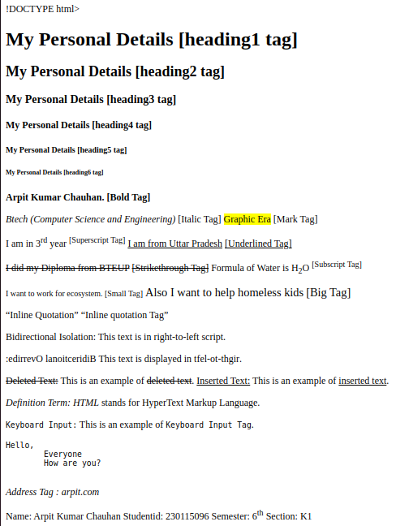

**Program No.:2**

**Program Title**

Write an HTML code to draw the following Figure.

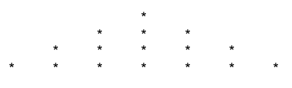

**Code**

<!DOCTYPE html>

<html lang="en">

<head>

<meta charset="UTF-8">

<meta name="viewport" content="width=device-width, initial-scale=1.0">

<title>Pyramid Shape</title>

</head>

<body>

<pre>

*

* * *

* * * * *

* * * * * * *

</pre>

<p>Name: Arpit Kumar Chauhan Studentid: 230115096 Semester: 6<sup>th</sup> Section: K1 </p>

</body>

</html>

**Screenshot of the output of program 2:-**

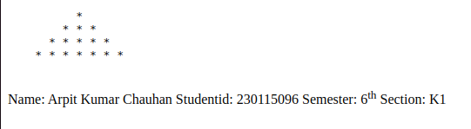

**Program No.:3**

**Program Title**

Create a web page to print the following table:

**Code**

<!DOCTYPE html>

<html lang="en">

<head>

<meta charset="UTF-8">

<meta name="viewport" content="width=device-width, initial-scale=1.0">

<title>Table</title>

</head>

<body>

<center>

<table border="1px">

<h3>List of Course-wise Subjects</h3>

<tr>

<th rowspan="2">

Sr.No.

</th>

<th rowspan="2">

Course

</th>

<th rowspan="2">

Subject

</th>

<th colspan="2">

Marks

</th>

<th colspan="2">

Category

</th>

<th rowspan="2">

Parctical Theory

</th>

</tr>

<tr>

<th>

Internal

</th>

<th>External</th>

<th>Internal</th>

<th>External</th>

</tr>

<tr>

<td rowspan="4">

1

</td>

<td rowspan = "4">MBA</td>

<td>

Management Accounting

</td>

<td>30</td>

<td>70</td>

<td>-</td>

<td>&#10004</td>

<td>Theory</td>

</tr>

<tr>

<td>Information Technolgy</td>

<td>30</td>

<td>70</td>

<td>-</td>

<td>&#10004</td>

<td>Theory</td>

</tr>

<tr>

<td>Basic of Marketing</td>

<td>30</td>

<td>70</td>

<td>-</td>

<td>&#10004</td>

<td>Theory</td>

</tr>

<tr>

<td>E-Commerce</td>

<td>50</td>

<td>-</td>

<td>&#10004</td>

<td>-</td>

<td>Theory</td>

</tr>

<tr>

<td rowspan="6">2</td>

<td rowspan = "6">MBA</td>

<td>Visual Basics</td>

<td>30</td>

<td>70</td>

<td>-</td>

<td>&#10004</td>

<td>T and P</td>

</tr>

<tr>

<td>Internet Technology</td>

<td>30</td>

<td>70</td>

<td>-</td>

<td>&#10004</td>

<td>T and P</td>

</tr>

<tr>

<td>Network Technology</td>

<td>30</td>

<td>70</td>

<td>-</td>

<td>&#10004</td>

<td>Theory</td>

</tr>

<tr>

<td>VB.Net</td>

<td>50</td>

<td>70</td>

<td>-</td>

<td>&#10004</td>

<td>T and P</td>

</tr>

<tr>

<td>Linux</td>

<td>30</td>

<td>70</td>

<td>-</td>

<td>&#10004</td>

<td>T and P</td>

</tr>

<tr>

<td>ISA</td>

<td>50</td>

<td>-</td>

<td>&#10004</td>

<td>-</td>

<td>Theory</td>

</tr>

</table>

<p>Name: Arpit Kumar Chauhan Studentid: 230115096 Semester: 6<sup>th</sup> Section: K1 </p>

</center>

</body>

</html>

**Screenshot of the output of program 3:-**

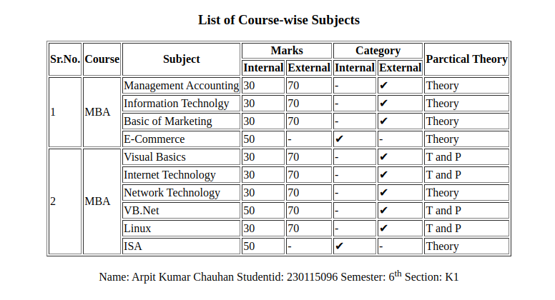

**Program No.:4**

**Program Title**

Using table related tags align the image with hyperlinks.

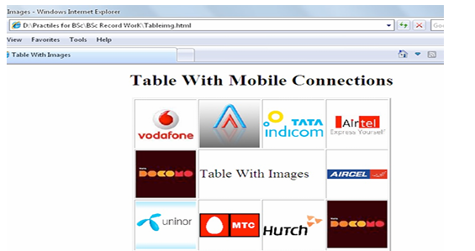

**Code**

<!DOCTYPE html>

<html lang="en">

<head>

<meta charset="UTF-8">

<meta name="viewport" content="width=device-width, initial-scale=1.0">

<title>Table</title>

</head>

<body>

<center>

<table border="1px">

<h2>Table With Mobile Connections</h2>

<tr>

<td><a href="https://www.vodafone.com/"><img src="vodafone.png" alt="Vodafone" width="150" height="130">

</a></td>

<td><a href="https://www.rcom.co.in/"><img src="reliancecomm.png" alt="reliancecomm" width="150" height="130">

</a></td>

<td><a href="https://www.tata.com/business/tata-teleservices"><img src="tataindicom.jpeg" alt="tataindicom" width="150" height="130">

</a></td>

<td><a href="https://www.airtel.com/"><img src="airtel.jpeg" alt="airtel.png" width="150" height="130">

</a></td>

</tr>

<tr>

<td><a href="https://en.wikipedia.org/wiki/Tata_Docomo"><img src="docomo.jpeg" alt="docomo" width="150" height="130"></a></td>

<td colspan="2"><center><h1>Table With Images</h1></center></td>

<td><a href="http://www.aircel.com/"><img src="aircel.jpeg" alt="aircel" width="150" height="130"></a></td>

</tr>

<tr>

<td><a href="https://www.telenor.com/"><img src="uninor.jpeg" alt="Telenor" width="150" height="130"></a></td>

<td><a href="https://mtc.com.na/"><img src="mtc.jpeg" alt="MTC" width="150" height="130"></a></td>

<td><a href="https://hutch.lk/"><img src="hutch.png" alt="HUTCH" width="150" height="130"></a></td>

<td><a href="https://en.wikipedia.org/wiki/Tata_Docomo"><img src="docomo.png" alt="Docomo" width="150" height="130"></a></td>

</tr>

</table>

<p>Name: Arpit Kumar Chauhan Studentid: 230115096 Semester: 6<sup>th</sup> Section: K1 </p>

</center>

</body>

</html>

**Screenshot of the output of program 4:-**

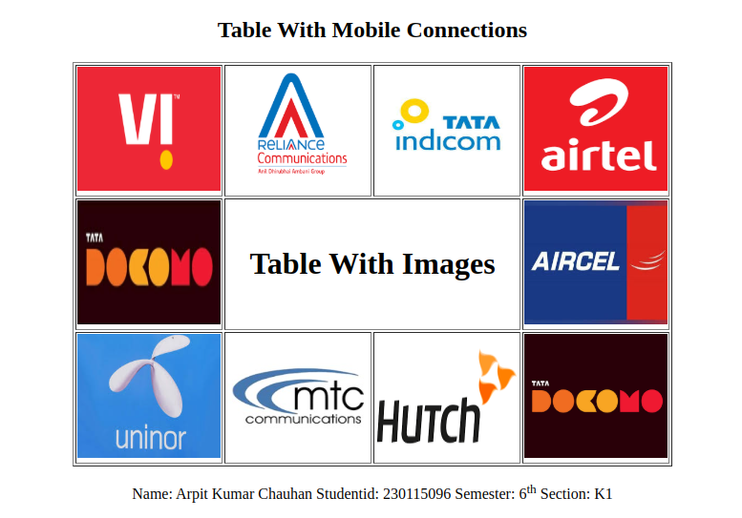

**Program No.:5**

**Program Title**

Create a web page with the following using HTML:

I. To embed an image map in a web page

II. To fix the hot spots

III. Show all the related information when the hot spots are clicked.

**Code**

<!DOCTYPE html>

<html lang="en">

<head>

<meta charset="UTF-8">

<meta name="viewport" content="width=device-width, initial-scale=1.0">

<title>Image Map Example</title>

</head>

<body>

<h1>Indian Flag</h1>

<img src="flag.jpg" alt="Indian Flag Image" usemap="#imagemap" >

<map name="imagemap">

<area shape="circle" coords="239,320,43" alt="Hotspot" href="https://www.india.gov.in/">

</map>

<p>Name: Arpit Kumar Chauhan Studentid: 230115096 Semester: 6<sup>th</sup> Section: K1 </p>

</body>

</html>

**Screenshot of the output of program 5:-**

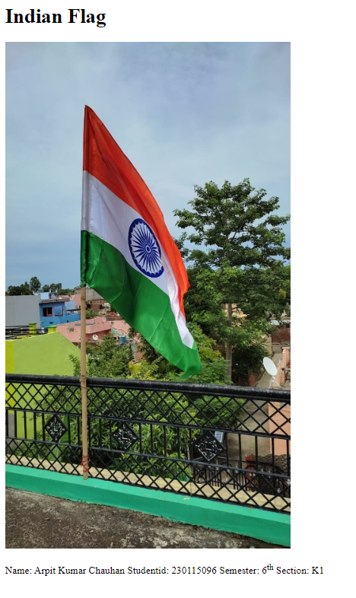

**After clicking on the Ashoka Chakra, you visit on the** [**https://www.india.gov.in/**](https://www.india.gov.in/) **website**

**Program No.:6**

**Program Title**

Create a web page having frames as follows:

The frame which includes Objective, Personal Information ect. are the hyperlinks. Display the relevant information in the next frame on selecting the link. The information should be well formatted. Follow the instructions mentioned in the above format.

**Code**

**<main.html>**

<!DOCTYPE html>

<html lang="en">

<head>

<meta charset="UTF-8">

<meta name="viewport" content="width=device-width, initial-scale=1.0">

<title>Image Map Example</title>

</head>

<body>

<center>

    <table border="1px">

        <tr>

            <th>Arpit Kumar Chauhan<br> I am an Web Developer </th>

        </tr>

        <tr>

            <th>

            <iframe src="1stframe.html"  frameborder="1px"></iframe>

            <iframe src="2ndframe.html" name="contentFrame" frameborder="1px"></iframe>

            <iframe src="flag.jpg"  frameborder="1px"></iframe>

            </th>

        </tr>

        <tr>

            <th><p>Name: Arpit Kumar Chauhan Studentid: 230115096 Semester: 6<sup>th</sup> Section: K1 </p></th>

        </tr>

    </table>

</center>

</body>

</html>

**<1stframe.html>**

<!DOCTYPE html>

<html>

<head>

    <title>Web Page with iFrames</title>

</head>

<body>

    <a href="objective.html" target="contentFrame">Objective</a><br>

    <a href="personal.html" target="contentFrame">Personal Information</a><br>

    <a href="family.html" target="contentFrame">Family Information</a><br>

    <a href="edu.html" target="contentFrame">Educational Information</a><br>

    <a href="exp.html" target="contentFrame">Experience</a><br>

    <a href="achiv.html" target="contentFrame">Achievements</a><br>

    <a href="others.html" target="contentFrame">Other</a><br>

</body>

</html>

**<2ndframe.html>**

<!DOCTYPE html>

<html lang="en">

<head>

    <meta charset="UTF-8">

    <meta name="viewport" content="width=device-width, initial-scale=1.0">

    <title>Document</title>

</head>

<body>

    <h3>Hello</h3>

</body>

</html>

**Screenshot of the output of program 6:-**

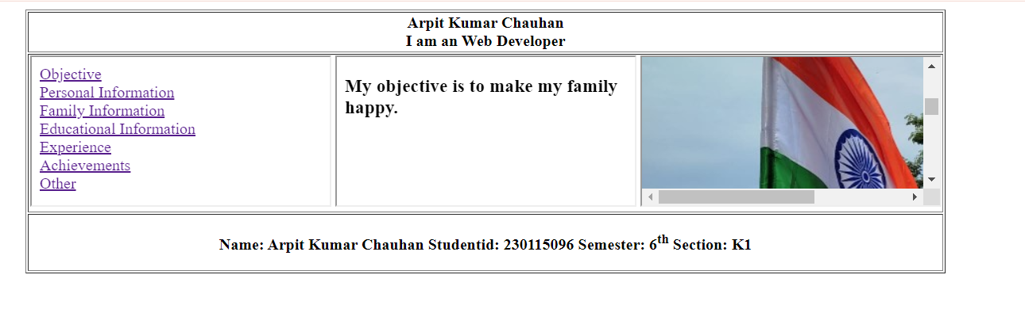

**Program No.:7**

**Program Title**

Write a HTML code for the following snapshot.

**Code**

<!DOCTYPE html>

<html>

<head>

<title>Form</title>

</head>

<body>

<center>

<table width="50%">

<tr>

<td>

<form action="#action">

<fieldset>

<legend>Basic Information</legend>

<label for="fullname">Full name:</label>

<input type="text" id="fullname" name="fullname"><br><br>

<label for="birthdate">Birth date:</label>

<input type="date" id="birthdate" name="birthdate"><br><br>

<label>Gender:</label>

<input type="radio" id="male" name="gender" value="male">

<label for="male">Male</label>

<input type="radio" id="female" name="gender" value="female">

<label for="female">Female</label><br><br>

<label for="address">Address:</label>

<input type="text" id="address" name="address"><br><br>

<label for="phone">Phone number:</label>

<input type="text" id="phone" name="phone"><br><br>

</fieldset>

<fieldset>

<legend>Extra Information</legend>

<label>Interests:</label>

<input type="checkbox" id="books" name="interests" value="Books">

<label for="books">Books</label>

<input type="checkbox" id="movies" name="interests" value="Movies">

<label for="movies">Movies</label>

<input type="checkbox" id="videogames" name="interests" value="Videogames">

<label for="videogames">Videogames</label><br><br>

<label for="color">Favorite color:</label>

<input type="color" id="color" name="color"><br><br>

</fieldset>

<br>

<button type="submit">Send data</button>

<button type="reset">Reset form</button>

</form>

</td>

</tr>

</table>

<p>Name: Arpit Kumar Chauhan Student ID: 230115096 Semester: 6<sup>th</sup> Section: K1</p>

</center>

</body>

</html>

**Screenshot of the output of program 7:-**

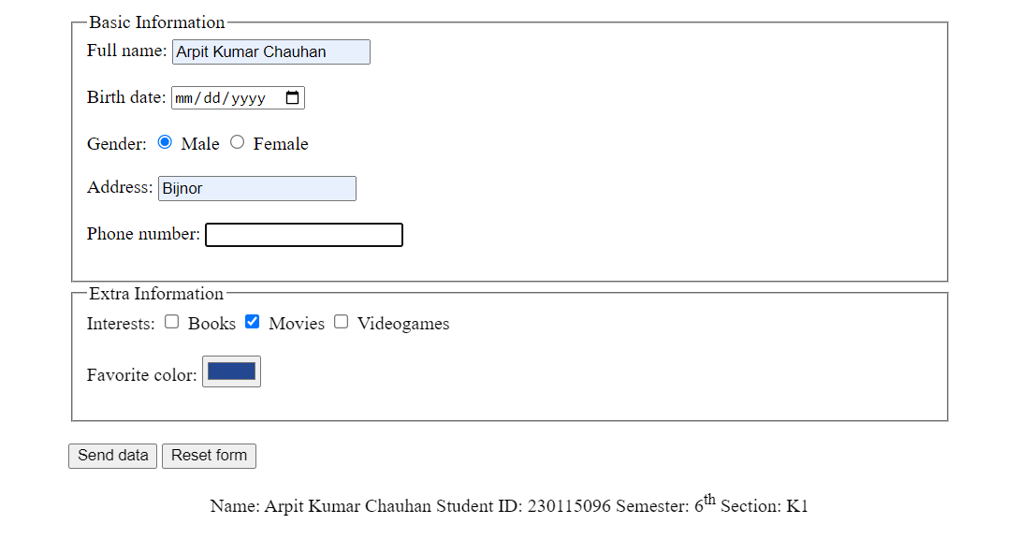

**Program No.:8**

**Program Title**

Create a web page of customer profile for data entry of customers in a Hotel, The profile should include Name, Address, Age, gender, Room Type (A/C, Non-A/C or Deluxe), Type of payment (Cash, Credit/Debit Card or Coupons).

**Code**

<!DOCTYPE html>

<html>

<head>

<title>Hotel Customer Profile</title>

</head>

<body>

<center>

<form action="#action">

<label for="name">Name:</label>

<input type="text" id="name" name="name" required><br><br>

<label for="address">Address:</label>

<input type="text" id="address" name="address" required><br><br>

<label for="age">Age:</label>

<input type="number" id="age" name="age" required><br><br>

<label for="gender">Gender:</label>

<select id="gender" name="gender" required>

<option value="male">Male</option>

<option value="female">Female</option>

<option value="other">Other</option>

</select><br><br>

<label for="room">Room Type:</label>

<select id="room" name="room" required>

<option value="ac">A/C</option>

<option value="non-ac">Non-A/C</option>

<option value="deluxe">Deluxe</option>

</select><br><br>

<label for="payment">Type of Payment:</label>

<select id="payment" name="payment" required>

<option value="cash">Cash</option>

<option value="card">Credit/Debit Card</option>

<option value="coupon">Coupons</option>

</select><br><br>

<input type="submit" value="Submit">

</form>

<p>Name: Arpit Kumar Chauhan Studentid: 230115096 Semester: 6<sup>th</sup> Section: K1 </p>

</center>

</body>

</html>

**Screenshot of the output of program 8:-**

**Program No.:9**

**Program Title**

Demonstrate the use of following HTML5 Tags:

1. <video>
2. <audio>
3. <header>
4. <footer>
5. <nav>
6. <embed>
7. <Datalist>
8. <bdi>
9. <article>
10. <output>

**Code**

<!DOCTYPE html>

<html>

<head>

<title>HTML5 Tags Demonstration</title>

</head>

<body>

<header>

<h1>Welcome to Our Hotel (header)</h1>

</header>

<nav>

<ul>

<h2>(nav)</h2>

<li><a href="#home">Home</a></li>

<li><a href="#about">About Us</a></li>

<li><a href="#contact">Contact</a></li>

</ul>

</nav>

<article>

<h2>(article)</h2>

<p>I am best.</p>

</article>

<h2>Video</h2>

<video width="320" height="240" controls>

<source src="flag.mp4" type="video/mp4">

<p>My browser does not support the video tag. So,I use iframe.</p>

</video>

<iframe src="falag.mp4"></iframe>

<h2>(audio)</h2>

<audio controls>

<source src="anthem.mp3" type="audio/mpeg">

</audio>

<h2>Gender</h2>

<form>

<h2>(datalist)</h2>

<label for="gender">Choose Gender:</label>

<input list="genders" id="gender" name="gender">

<datalist id="genders">

<option value="Male"></option>

<option value="Female"></option>

<option value="Other"></option>

</datalist>

<br><br>

<label for="payment">Payment Amount:</label>

<input type="number" id="amount" name="amount">

<output for="amount" id="total">output</output>

<br><br>

<input type="submit" value="Book Now">

</form>

<h2>(Embed)</h2>

<embed src="HTML [PCS-693].pdf" width="600" height="400" type="application/pdf">

<h2>Bdi</h2>

<p><bdi>مرحبًا</bdi> means "Welcome" in Arabic.</p>

<footer>

<h2>(Footer)</h2>

<p><>Name: Arpit Kumar Chauhan Studentid: 230115096 Semester: 6<sup>th</sup> Section: K1 </p>

</footer></body>

</html>

**Screenshot of the output of program 9:-**

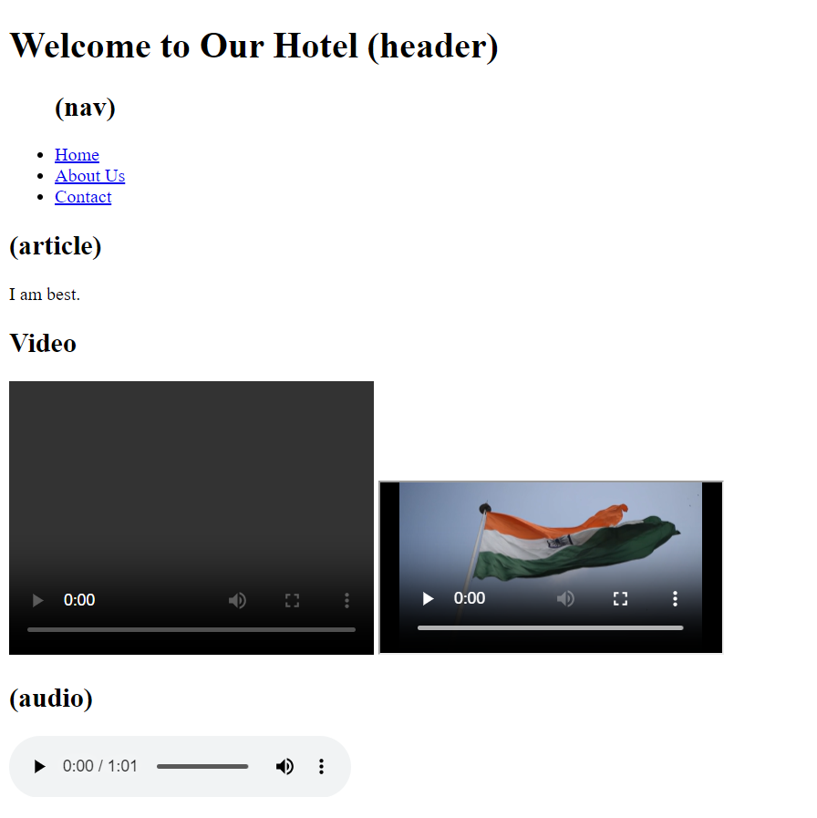

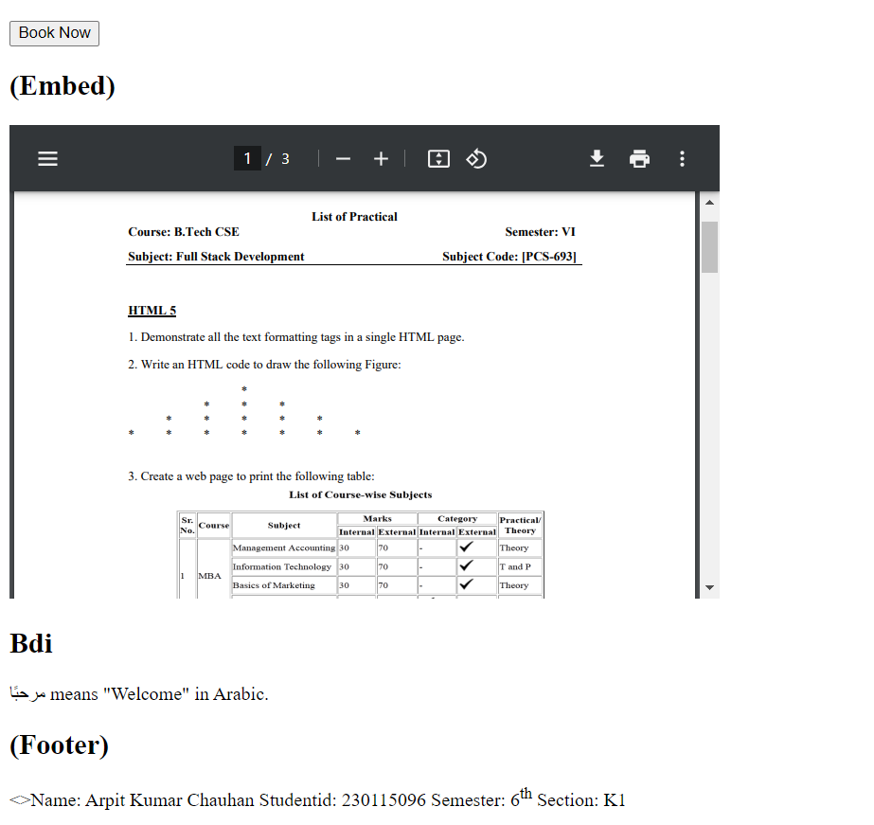

**Program No.:10**

**Program Title**

Design an HTML page to create the following list.

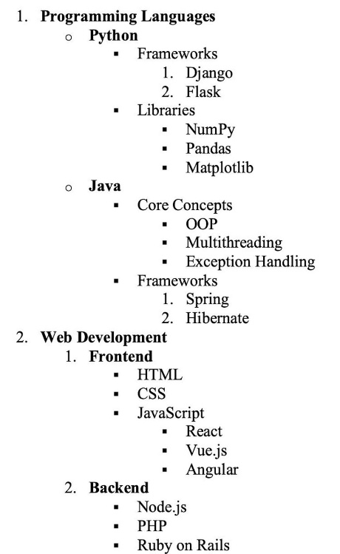

**Code**

<!DOCTYPE html>

<html lang="en">

<head>

<meta charset="UTF-8">

<meta name="viewport" content="width=device-width, initial-scale=1.0">

<title>HTML list</title>

</head>

<body>

<ol>

<li><b>Programming Languages</b>

<ul>

<li><b>Python</b>

<ul>

<li>Frameworks

<ol>

<li>Django</li>

<li>Flask</li>

</ol>

</li>

<li>Libraries

<ul>

<li>NumPy</li>

<li>Pandas</li>

<li>Matplotlib</li>

</ul>

</li>

</ul>

</li>

<li><b>Java</b>

<ul>

<li>Core Concepts

<ul>

<li>OOP</li>

<li>Multithreading</li>

<li>Exception Handling</li>

</ul>

</li>

<li>

Frameworks

<ul>

<li>Spring</li>

<li>Hibernate</li>

</ul>

</li>

</ul>

</li>

</ul>

</li>

<li><b>Web Development</b>

<ol>

<li><b>Frontend</b>

<ul>

<li>HTML</li>

<li>CSS</li>

<li>JavaScript

<ul>

<li>React</li>

<li>Vue.js</li>

<li>Angular</li>

</ul>

</li>

</ul>

</li>

<li><b>Backend</b>

<ul>

<li>Node.js</li>

<li>PHP</li>

<li>Ruby on Rails</li>

</ul>

</li>

</ol>

</li>

</ol>

<p>Name: Arpit Kumar Chauhan Studentid: 230115096 Semester: 6<sup>th</sup> Section: K1 </p>

</body>

</html>

**Screenshot of the output of program 10:-**

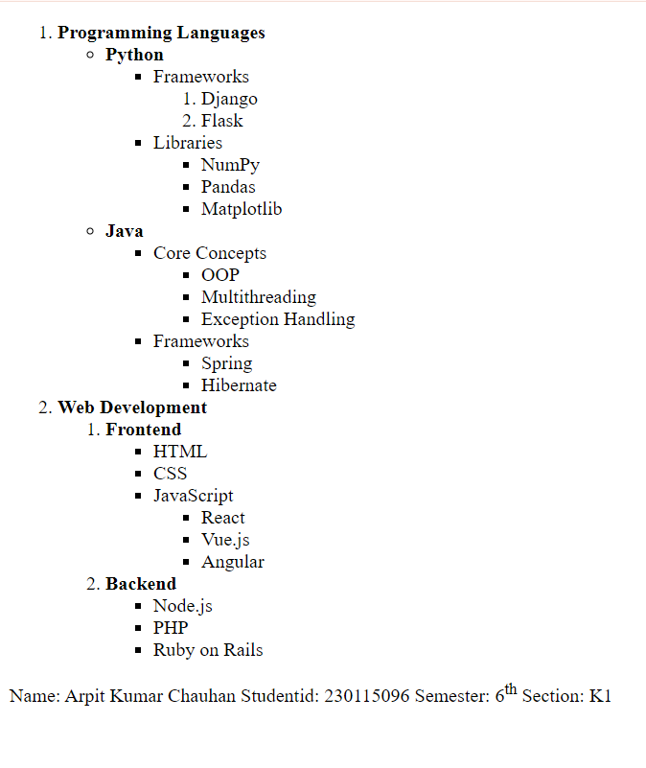

**Program No.:11**

**Program Title**

Create a web page to show all hyperlinks with following specification:

* Default color pink
* Active color is blue
* Visited color is Green
* Hyperlink should be without underlines

**Code**

<!DOCTYPE html>

<html lang="en">

<head>

<meta charset="UTF-8">

<meta name="viewport" content="width=device-width, initial-scale=1.0">

<title>Hyperlink Styling</title>

<style>

.box {

border: 2px solid;

height: auto;

padding: 20px;

width: 40%;

max-width: 400px;

text-align: center;

margin: auto;

}

a {

font-size: 2rem;

color: pink;

text-decoration: none;

font-weight: bold;

}

a:active {

color: blue;

}

a:visited {

color: green;

}

</style>

</head>

<body>

<div class="box">

<a href="#" target="_blank">Click Me!</a> <br><br>

<p>

Name: Arpit Kumar Chauhan Student ID: 230115096 Semester: 6<sup>th</sup> Section: K1

</p>

</div>

</body>

</html>

**Screenshot of the output of program 11:-**

**Before visited**

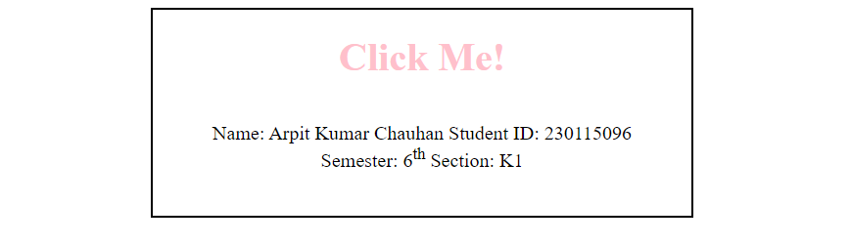

**After visited**

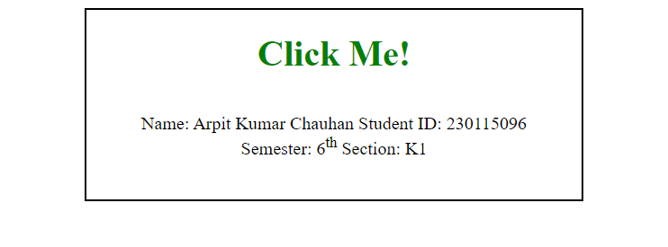

**On click()active**

**Program No.:12**

**Program Title**

Create Box Shadow and text Shadow using CSS3.

**Code**

<!DOCTYPE html>

<html lang="en">

<head>

    <meta charset="UTF-8">

    <meta name="viewport" content="width=device-width, initial-scale=1.0">

    <title>2nd css</title>

    <style>

        .main {

            border: 5px solid aqua;

            width: 50%;

            margin: 50px auto;

            padding: 20px;

            text-align: center;

        }

        .box {

            box-shadow: 4px 4px 10px rgba(0, 0, 0, 1);

            background-color: #d05022;

            text-shadow: 6px 6px 10px rgb(173, 223, 10);

            height: 200px;

            padding: 20px;

            font-size: 30px;

            color: greenyellow;

            width: 80%;

            text-align: center;

            margin: 30px auto;

            display: flex;

            align-items: center;

            justify-content: center;

        }

    </style>

</head>

<body>

    <div class="main">

        <div class="box">

            <strong>Arpit Kumar Chauhan</strong>

        </div>

        <p>

            <p>

                Name: Arpit Kumar Chauhan Student ID: 230115096 Semester: 6<sup>th</sup> Section: K1

            </p>

        </p>

    </div>

</body>

</html>

**Screenshot of the output of program 12:-**

**Program No.:13**

**Program Title**

Create a Rounded Corners using css3.

**Code**

<!DOCTYPE html>

<html lang="en">

<head>

<meta charset="UTF-8">

<meta name="viewport" content="width=device-width, initial-scale=1.0">

<title>Document</title>

<style>

.main {

border: 5px solid aqua;

width: 30%;

margin: 50px auto;

padding: 20px;

text-align: center;

}

.border{

border-radius: 10px;

background-color: brown;

height:100px;

width:100p;

margin:50px 50px;;

text-align: center;

}

</style>

</head>

<body>

<div class="main">

<div class="border"></div>

<p>

Name: Arpit Kumar Chauhan Student ID: 230115096 Semester: 6<sup>th</sup> Section: K1

</p>

</div>

</body>

</html>

**Screenshot of the output of program 13:-**

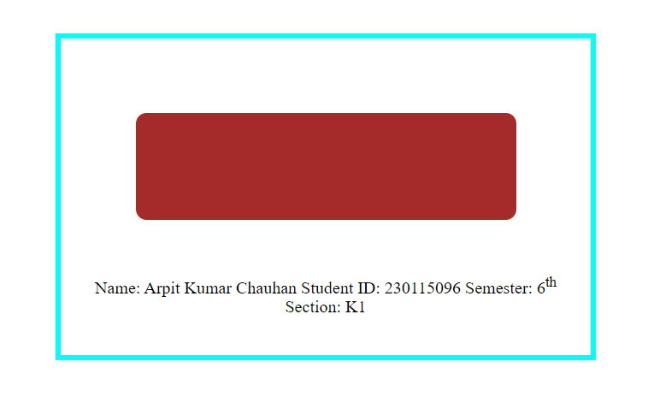

**Program No.:14**

**Program Title**

Create a webpage to show newspaper layout effects on contents given in webpage (i.e. in multiple columns).

**Code**

<!DOCTYPE html>

<html lang="en">

<head>

<meta charset="UTF-8">

<meta name="viewport" content="width=device-width, initial-scale=1.0">

<title>Newspaper</title>

<style>

.main{

border:4px solid aqua;

height: auto;

width: 60%;

text-align: center;

margin: 50px auto;

}

.news

{

background:whitesmoke;

columns:3;

text-align: justify;

margin:20px;

}

.news h2{

column-span:all;

text-align: center;

margin:10px;

border-bottom: 2px solid rgb(27, 26, 26);

}

header{

column-span: all;

text-align: center;

border-bottom: 3px solid rgb(27, 26, 26);

}

</style>

</head>

<body>

<div class="main">

<div class="news">

<header><h1>Todays Daily</h1></header>

<h2>CSS Creates Amazing Layouts!</h2>

CSS has revolutionized web design by allowing developers to create visually stunning newspaper-style layouts with ease. The `columns` property enables text to flow seamlessly across multiple columns, mimicking traditional print newspapers.

Web developers around the world are now adopting these techniques to enhance user readability and create engaging web pages. With CSS3, features like `column-span`, `column-gap`, and `column-rule` provide a more refined and structured layout.

Experts believe that such innovations will continue to shape the future of digital content. By using simple yet powerful CSS properties, designers can bring a fresh look to online journalism, blogs, and news portals.

<h2>Technology and Future Trends</h2>

The world of web development is constantly evolving, and CSS advancements play a crucial role in shaping modern interfaces. Responsive design, flexbox, and grid layouts have changed the way developers build interactive websites.

Multi-column layouts are widely used in magazines, blogs, and news websites to present information in a visually appealing manner. This technique improves readability and enhances the overall aesthetic of a webpage.

As technology advances, more tools and frameworks will emerge, making it easier to design complex layouts without extensive coding. Web designers are encouraged to experiment with different CSS techniques to achieve the best results.

</div>

<p>Name: Arpit Kumar Chauhan Student ID: 230115096 Semester: 6<sup>th</sup> Section: K1</p>

</div>

</body>

</html>

**Screenshot of the output of program 14:-**

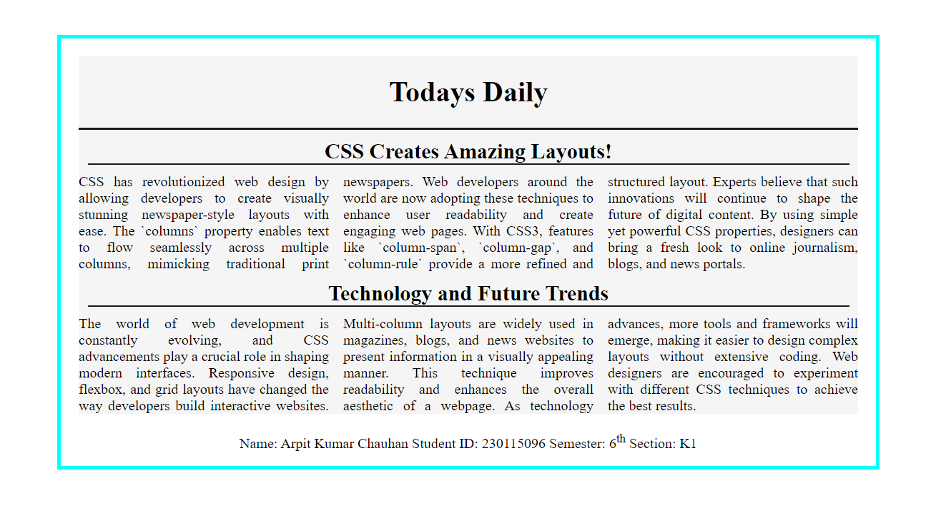

**Program No.:15**

**Program Title**

Create a webpage to show transition effect in such a way so that elements gradually change from one style to another.

**Code**

<!DOCTYPE html>

<html lang="en">

<head>

<meta charset="UTF-8">

<meta name="viewport" content="width=device-width, initial-scale=1.0">

<title>Document</title>

<style>

.main{

border:4px solid aqua;

margin:50px auto;

width:40%;

height:40%;

padding-top: 20px;

text-align:center;

}

.tr{

background:brown;

width: 50%;

height: 50px;

margin: auto;

text-align: center;

transition : background-color 2s , transform 2s;

}

.tr:hover{

background:gray;

transform: scale(1.5);

}

</style>

</head>

<body>

<div class="main">

<div class="tr"></div>

<p>Name: Arpit Kumar Chauhan Studentid: 230115096 Semester: 6<sup>th</sup> Section: K1 </p>

</div>

</body>

</html>

**Screenshot of the output of program 15:-**

**Before transition**

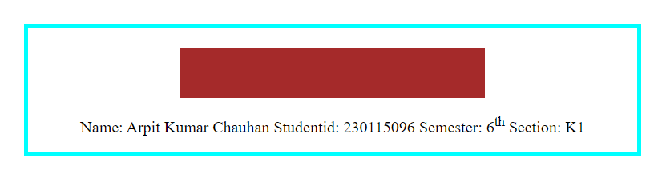

**After transition**

**Program No.:16**

**Program Title**

Create a web page to show fixed background image (this image will not scroll with the rest of the page).

**Code**

<!DOCTYPE html>

<html lang="en">

<head>

<meta charset="UTF-8">

<meta name="viewport" content="width=device-width, initial-scale=1.0">

<title>Fixed Background</title>

<style>

.main {

margin: 20px;

font-family: Arial, sans-serif;

background-image: url('flag.jpg');

background-attachment: fixed;

background-size: cover;

background-position: center center;

color: white;

}

.content {

margin: 50px auto;

background-color: rgba(0, 0, 0, 0.7);

padding: 20px;

border-radius: 10px;

}

.space {

height: 60vh;

}

.b {

border: 4px solid aqua;

text-align: center;

}

</style>

</head>

<body>

<div class="b">

<div class="main">

<div class="content">

<h1>Welcome to My Page</h1>

</div>

<div class="space"></div>

<div class="content">

<h2>More Content</h2>

<p>As you scroll, the background remains fixed while the content moves.</p>

</div>

<div class="space"></div>

</div>

<p>Name: Arpit Kumar Chauhan Studentid: 230115096 Semester: 6<sup>th</sup> Section: K1 </p>

</div>

</body>

</html>

**Screenshot of the output of program 16:-**

**Program No.:17**

**Program Title**

Create a web page to position a background image and repeat the image horizontally or vertically.

**Code**

<!DOCTYPE html>

<html lang="en">

<head>

<meta charset="UTF-8">

<meta name="viewport" content="width=device-width, initial-scale=1.0">

<title>Fixed Background</title>

<style>

.main {

margin: 20px;

font-family: Arial, sans-serif;

background-image: url('flag.jpg');

background-attachment: fixed;

background-repeat: repeat;

color: white;

}

.content {

margin: 50px auto;

background-color: rgba(0, 0, 0, 0.7);

padding: 20px;

border-radius: 10px;

}

.space {

height: 60vh;

}

.b {

border: 4px solid aqua;

text-align: center;

}

</style>

</head>

<body>

<div class="b">

<div class="main">

<div class="content">

<h1>Welcome to My Page</h1>

</div>

<div class="space"></div>

<div class="content">

<h2>More Content</h2>

<p>As you scroll, the background remains fixed while the content moves.</p>

</div>

<div class="space"></div>

</div>

<p>Name: Arpit Kumar Chauhan Studentid: 230115096 Semester: 6<sup>th</sup> Section: K1 </p>

</div>

</body>

</html>

**Screenshot of the output of program 17:-**

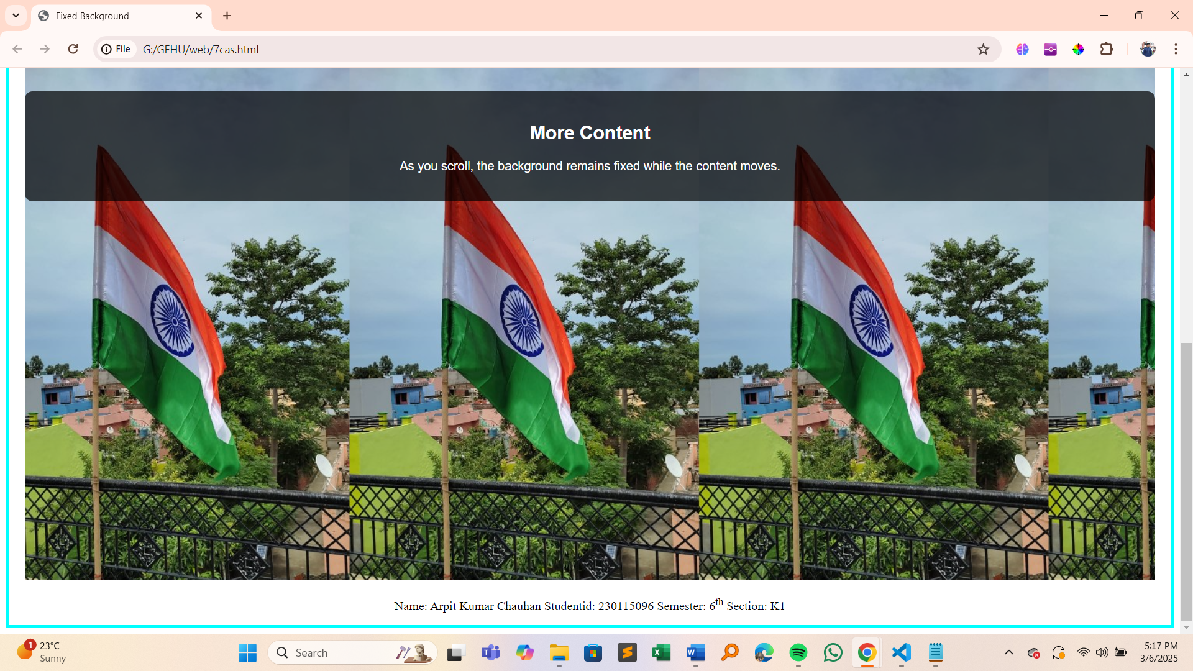

**Program No.:18**

**Program Title**

Create an HTML page to demonstrate all types of CSS position properties (static,

relative, absolute, fixed, and sticky).

**Code**

<!DOCTYPE html>

<html lang="en">

<head>

<meta charset="UTF-8">

<meta name="viewport" content="width=device-width, initial-scale=1.0">

<title>CSS Position Properties</title>

<style>

body {

padding: 50px;

}

.main {

width: 100%;

height: 80vh;

border: 4px solid aqua;

text-align: center;

padding:20px;

}

.static {

position: static;

background:gray;

}

.relative {

position: relative;

top: 30px;

left: 50px;

background-color: lightgreen;

}

.absolute {

position: absolute;

top: 100px;

right: 20%;

background-color: rgb(173, 216, 230,0.5);

}

.fixed {

position: fixed;

bottom: 30px;

right: 30px;

background-color: lightgoldenrodyellow;

}

.sticky {

position: sticky;

top: 0;

background-color: rgb(255, 182, 193,0.5);

padding: 10px;

margin:20px

}

.box{

height:10%;

width:15%;

}

</style>

</head>

<body>

<div class="main">

<h1>Position Property Demonstration</h1>

<div class="box static">Static Position</div>

<div class="box relative">Relative Position</div>

<div class="box absolute">Absolute Position</div>

<div class="box fixed">Fixed Position</div>

<div class="box sticky">Sticky Position</div>

<p>Name: Arpit Kumar Chauhan Studentid: 230115096 Semester: 6<sup>th</sup> Section: K1 </p>

</div>

</body>

</html>

**Screenshot of the output of program 18:-**

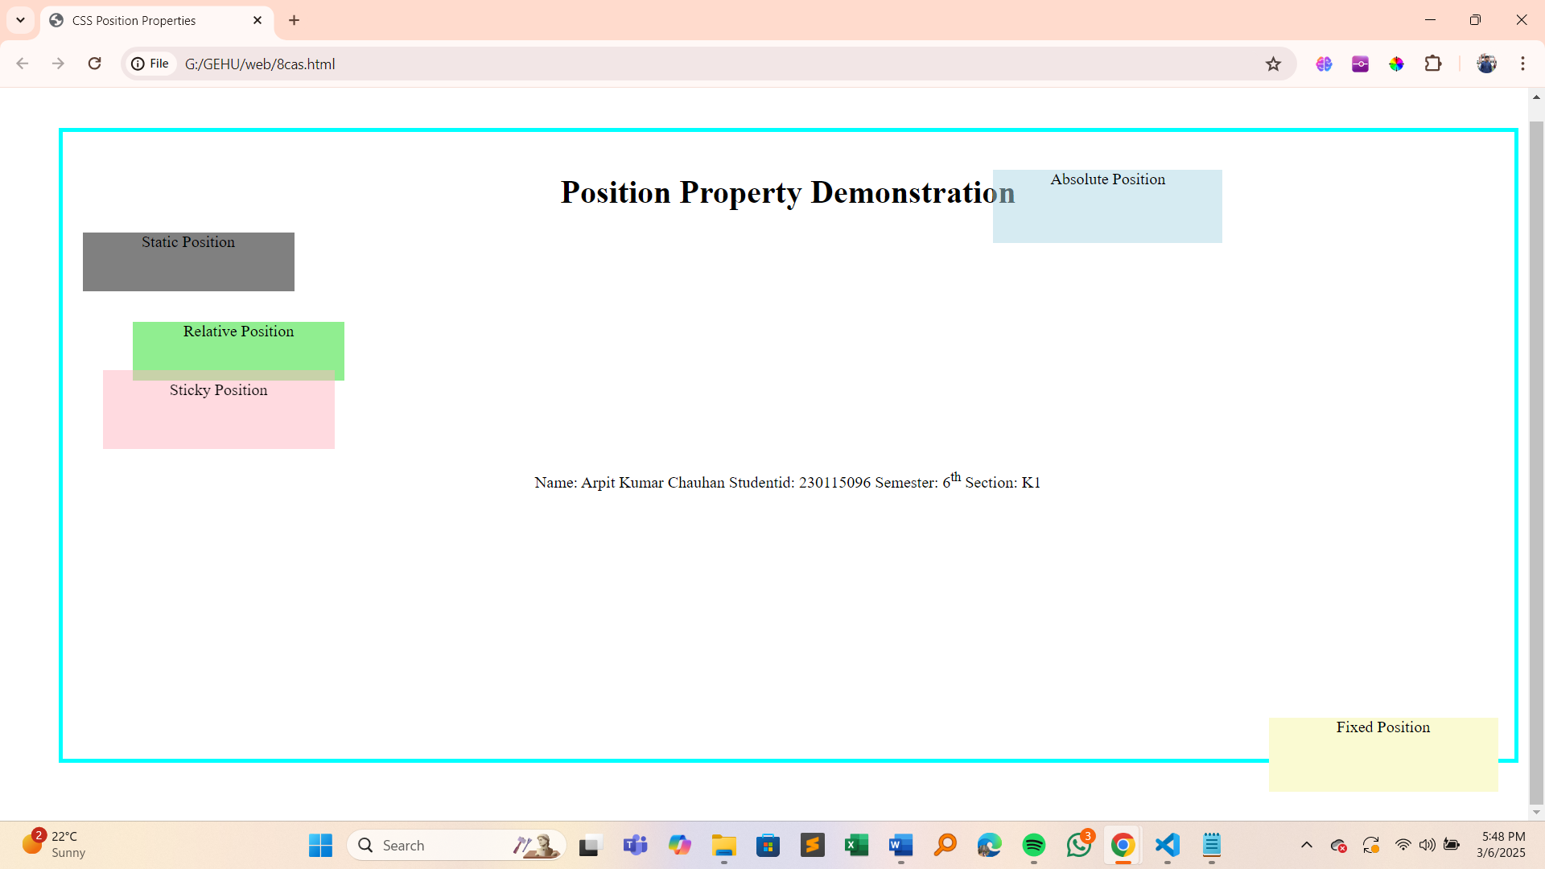

**Program No.:19**

**Program Title**

Design a web page using CSS which includes the following

1. Use different font styles.
2. Set background image for both the page and single elements on page.
3. Control the repetition of image with background-repeat property.
4. Define style for links as a:link, a:active, a:hover, a:visited.
5. Add customized cursors for links.
6. Work with layers.

**Code**

<!DOCTYPE html>

<html lang="en">

<head>

<meta charset="UTF-8">

<meta name="viewport" content="width=device-width, initial-scale=1.0">

<title>Styled Web Page</title>

<style>

body {

font-family: Arial, sans-serif;

background-image: url('youtube.png');

background-size: cover;

background-repeat: no-repeat;

background-attachment: fixed;

color: rgb(64, 45, 45);

text-align: center;

padding: 35px;

}

h1 {

font-family:'Times New Roman', Times, serif;

font-size: 36px;

font-weight: bold;

text-shadow: 2px 2px 5px black;

}

p {

font-family: 'Georgia', serif;

font-size: 18px;

}

.box {

width: 300px;

height: 150px;

background-image: url('flag.jpg');

background-size: cover;

background-repeat: no-repeat;

border: 2px solid rgb(65, 52, 52);

margin: 20px auto;

padding: 20px;

text-align: center;

font-weight: bold;

line-height: 150px;

position: relative;

z-index: 2;

}

.repeat-box {

width: 300px;

height: 150px;

background-image: url('ashok.png');

background-repeat: repeat;

border: 2px solid rgb(61, 52, 52);

margin: 20px auto;

padding: 20px;

text-align: center;

font-weight: bold;

line-height: 150px;

position: relative;

z-index: 2;

}

a {

font-size: 20px;

text-decoration: none;

padding: 10px;

border-radius: 5px;

transition: all 0.3s ease;

}

a:link {

color: yellow;

}

a:visited {

color: rgb(181, 42, 42);

}

a:hover {

color: orange;

text-decoration: underline;

}

a:active {

color: red;

}

a {

cursor: pointer;

}

.grab {

cursor: -webkit-grab;

cursor: grab;

}

.layer1 {

position: absolute;

top: 100px;

left: 50px;

width: 200px;

height: 200px;

background-color: rgba(0, 0, 255, 0.6);

z-index: 1;

border-radius: 10px;

}

.layer2 {

position: absolute;

top: 150px;

left: 100px;

width: 250px;

height: 200px;

background-color: rgba(255, 0, 0, 0.6);

z-index: 2;

border-radius: 10px;

}

p{

background: white;

display:inline;

}

</style>

</head>

<body>

<div class="grab">

<h1>Stylish Web Page</h1>

<p>This web page demonstrates various CSS features including fonts, background images, link styles, and layers.</p>

<div class="box"></div>

<div class="repeat-box"></div>

<p>Check out this <a href="9thcss.html" class="custom-cursor">cool link</a> with custom cursor!</p>

<div class="layer1"> Layer 1</div>

<div class="layer2"> Layer 2</div>

</div>

<p>Name: Arpit Kumar Chauhan Studentid: 230115096 Semester: 6<sup>th</sup> Section: K1 </p>

</body>

</html>

**Screenshot of the output of program 19:-**

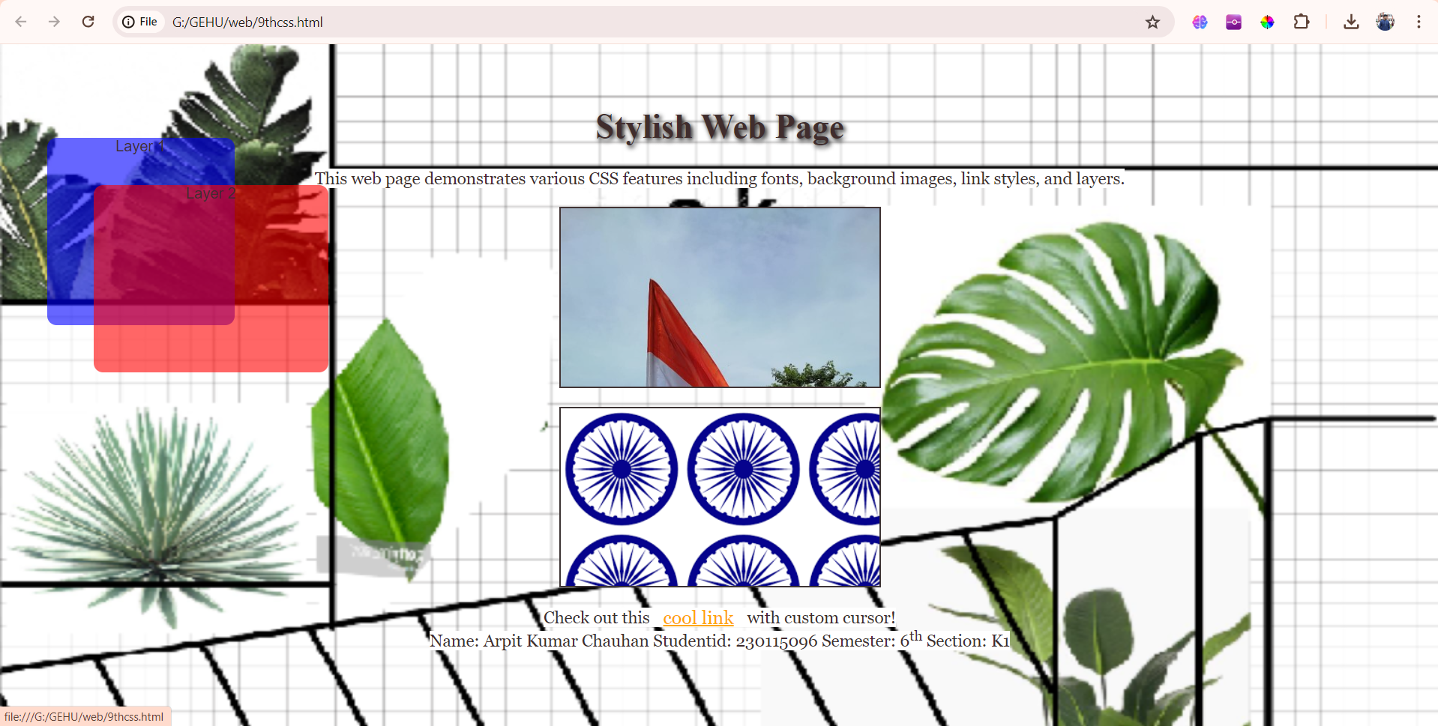

**Program No.:20**

**Program Title**

Design a web page to validate credit card numbers per the specifications below. The following tables outline the major credit cards you want to validate and allow prefixes and lengths.

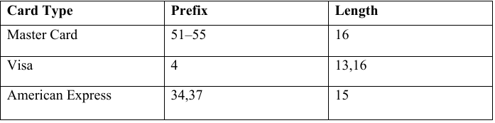

**Code**

<!DOCTYPE html>

<html lang="en">

<head>

    <meta charset="UTF-8">

    <meta name="viewport" content="width=device-width, initial-scale=1.0">

    <title>Form Validation</title>

    <style>

        #main

        {

            border:3px solid rgb(0, 187, 255);

            height:auto;

            width:600px;

            padding:20px;

            margin:20px auto;

            text-align: center;

            background: rgb(226, 234, 211);

        }

        button{

            background: rgb(122, 151, 241);

        }

    </style>

</head>

<body>

    <div id="main">

        Enter card Number

        <input type="number" id="in">

        <br><br>

        <button type="button" onclick="validate()">Validate</button>

        <br><br>

        <div id="out"></div>

  <p>Name: Arpit Kumar Chauhan Studentid: 230115096 Semester: 6<sup>th</sup> Section: K1 </p>

    </div>

    <script>

        function validate(){

            var c = document.getElementById('in').value;

            if((/^[51-55]/.test(c)) && (c.length==16)){

                document.getElementById('out').innerHTML='Valid MasterCard Number';

                document.getElementById('out').style.color='green';

            }

            else if((/^4/.test(c)) && ((c.length==13) || (c.length==16))){

                document.getElementById('out').innerHTML='Valid Visa Card Number';

                document.getElementById('out').style.color='green';

            }

            else if((/^[34,37]/.test(c)) && (c.length==15)){

                document.getElementById('out').innerHTML='Valid American Express Card Number';

                document.getElementById('out').style.color='green';

            } else {

                document.getElementById('out').innerHTML='!Invalid Card Number';

                document.getElementById('out').style.color='red';

            }

        }

    </script>

</body>

</html>

**Screenshot of the output of program 20:-**

**Invalid Card Number:**

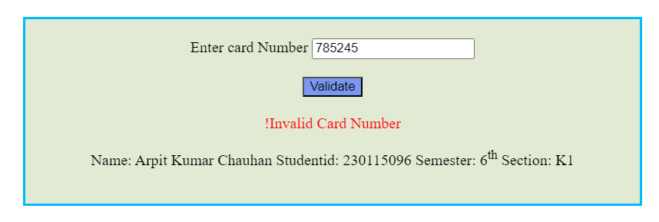

**Valid MasterCard Number:**

**Valid Visa Card Number:**

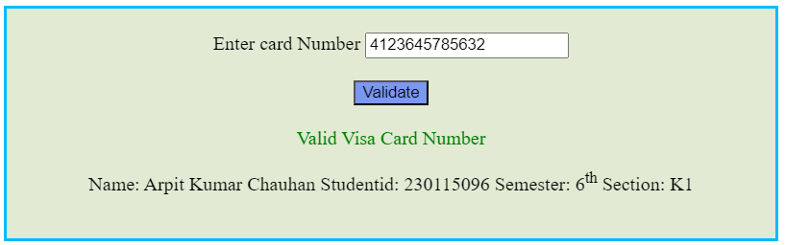

**Valid American Express Card Number:**

**Program No.:21**

**Program Title**

Design a web page to validate the following according to the standard conditions.

a. Name.

b. E-Mail-id.

c. Password.

**Code**

<!DOCTYPE html>

<html lang="en">

<head>

    <meta charset="UTF-8">

    <meta name="viewport" content="width=device-width, initial-scale=1.0">

    <title>Validate</title>

    <style>

        #main

        {

            border:3px solid rgb(0, 187, 255);

            height:auto;

            width:600px;

            padding:20px;

            margin:20px auto;

            text-align: center;

            background: rgb(226, 234, 211);

        }

        button{

            background: rgb(122, 151, 241);

        }

    </style>

</head>

<body>

    <div id="main">

        <label for="name">Name : </label>

        <input id="name" name="name" type="text">

        <br><br>

        <label for="mail">E-Mail : </label>

        <input id="mail" name="mail" type="text">

        <br><br>

        <label for="pass">Password : </label>

        <input id="pass" name="pass" type="text">

        <br><br>

        <button type="button" onclick="validate()">Validate</button><br><br>

        <div id="vn"></div>

        <div id="ve"></div>

        <div id="vp"></div>

        <p>Name: Arpit Kumar Chauhan Studentid: 230115096 Semester: 6<sup>th</sup> Section: K1 </p>

    </div>

    <script>

        function validate()

        {

            let user = document.getElementById('name').value;

            let mail = document.getElementById('mail').value;

            let pass = document.getElementById('pass').value;

            /*For name validation*/

            if(/^[a-zA-Z]+$/.test(user))

            {

                document.getElementById('vn').innerHTML='Valid Name';

                document.getElementById('vn').style.color='green';

                document.getElementById('name').style.border='2px solid green';

            }

            else

            {

                document.getElementById('vn').innerHTML='InValid Name';

                document.getElementById('vn').style.color='red';

                document.getElementById('name').style.border='2px solid red';

            }

            /*for Email validation*/

            if(/^[a-z]+[0-9_a-z]*@[a-z]+\.[a-z]{2,}$/.test(mail))

            {

                document.getElementById('ve').innerHTML='Valid E-mail';

                document.getElementById('ve').style.color='green';

                document.getElementById('mail').style.border='2px solid green';

            }

            else

            {

                document.getElementById('ve').innerHTML='InValid E-mail';

                document.getElementById('ve').style.color='red';

                document.getElementById('mail').style.border='2px solid red';

            }

            /*For Password validation*/

            if(/[a-zA-Z0-9@#][0-9]*[a-zA-Z@#0-9]+$/.test(pass) && (pass.length>=8))

            {

                document.getElementById('vp').innerHTML='Valid PassWord';

                document.getElementById('vp').style.color='green';

                document.getElementById('pass').style.border='2px solid green';

            }

            else

            {

                document.getElementById('vp').innerHTML='InValid PassWord';

                document.getElementById('vp').style.color='red';

                document.getElementById('pass').style.border='2px solid red';

            }

        }

    </script>

</body>

</html>

**Screenshot of the output of program 21:-**

**Success:**

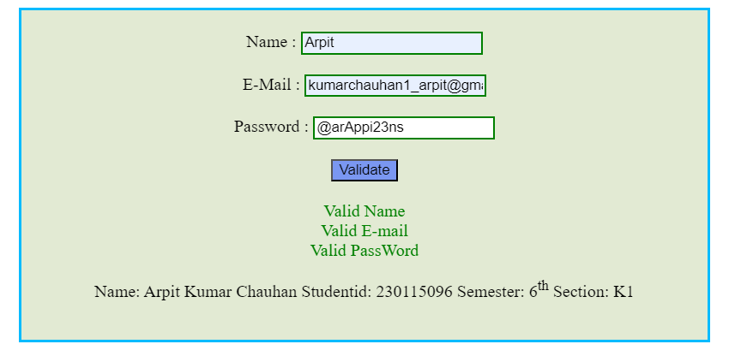

**Program No.:22**

**Program Title**

Store some country names and their capitals. Ask the user to select a country and its capital from two lists. If the match is correct, display “Correct answer”; otherwise, display an error message and tell the correct answer.

**Code**

<!DOCTYPE html>

<html lang="en">

<head>

    <meta charset="UTF-8">

    <meta name="viewport" content="width=device-width, initial-scale=1.0">

    <title>Country & Capital Quiz</title>

    <style>

        #main

        {

            border:4px solid aqua;

            height:auto;

            width:600px;

            margin:20px auto;

            padding:20px;

            text-align: center;

            background: rgb(226, 234, 211);

        }

        button{

            background: rgb(122, 151, 241);

        }

    </style>

</head>

<body>

    <div id="main">

        <h2>Match the Country with its Capital</h2>

        <label for="country">Country:</label>

        <select id="country">

            <option value="">Select Country</option>

            <option value="India">India</option>

            <option value="Japan">Japan</option>

            <option value="USA">USA</option>

            <option value="France">France</option>

            <option value="Germany">Germany</option>

            <option value="Pakistan">Pakistan</option>

            <option value="China">China</option>

        </select>

        <br><br>

        <label for="capital">Capital:</label>

        <select id="capital">

            <option value="">Select Capital</option>

            <option value="Washington D.C">Washington, D.C.</option>

            <option value="Delhi">New Delhi</option>

            <option value="Paris">Paris</option>

            <option value="Bejing">Bejing</option>

            <option value="Tokyo">Tokyo</option>

            <option value="Berlin">Berlin</option>

            <option value="Islamabad">Islamabad</option>

        </select>

        <br><br>

        <button onclick="checkAnswer()">Check Answer</button>

        <h4 id="result"></h4>

        <p>Name: Arpit Kumar Chauhan Studentid: 230115096 Semester: 6<sup>th</sup> Section: K1 </p>

    </div>

    <script>

        function checkAnswer()

        {

            let country = document.getElementById('country').value;

            let capital = document.getElementById('capital').value;

            let result = document.getElementById('result');

            const check = {

                "USA":"Washington D.C",

                "India":"Delhi",

                "France":"Paris",

                "China":"Bejing",

                "Japan":"Tokyo",

                "Pakistan":"Islamabad",

                "Germany":"Berlin"

            };

            if(!capital || !country)

            {

                result.innerHTML="Enter both Country and capital";

                result.style.color='red';

                document.getElementById('capital').style.border='2px solid red';

                document.getElementById('country').style.border='2px solid red';

            }

            else if(check[country]==capital){

                result.innerHTML="Correct Answer";

                result.style.color='green';

                document.getElementById('capital').style.border='2px solid green';

                document.getElementById('country').style.border='2px solid green';

            }

            else{

                result.innerHTML="Wrong Answer The capital of "+country+" is "+check[country]+".";

                result.style.color='red';

                capital.style.border='2px solid red';

            }

        }

        </script>

</body>

</html>

**Screenshot of the output of program 22:-**

**Program No.:23**

**Program Title**

Design the simple Calculator.

**Code**

<!DOCTYPE html>

<html lang="en">

<head>

    <meta charset="UTF-8">

    <meta name="viewport" content="width=device-width, initial-scale=1.0">

    <title>Form Validation</title>

    <style>

        #main{

            border:3px solid rgb(0, 187, 255);

            height:auto;

            width:600px;

            padding:20px;

            margin:20px auto;

            text-align: center;

            background: rgb(226, 234, 211);

        }

        button{

            background: rgb(122, 151, 241);

        }

    </style>

</head>

<body>

    <div id="main">

        <label for="first">Enter First Number:</label>

        <input type="number" id="first" name="first">

        <br><br>

        <label for="second">Enter Second Number:</label>

        <input type="number" id="second" name="second">

        <br><br>

        <label for="cal">Choose Option</label>

        <select name="cal" id="cal">

            <option value="+">Add</option>

            <option value="-">Substract</option>

            <option value="*">Multiply</option>

            <option value="/">Divide</option>

        </select>

        <br><br>

        <button type="button" onclick="validate()">Validate</button>

        <br><br>

        <label for="ans">Answer:</label>

        <input type="number" id="ans" name="ans">

        <br><br>

        <div id="out"></div>

        <p>Name: Arpit Kumar Chauhan Studentid: 230115096 Semester: 6<sup>th</sup> Section: K1 </p>

    </div>

    <script>

        function validate(){

            let f = document.getElementById('first').value;

            let s = document.getElementById('second').value;

            let a = document.getElementById('cal').value;

            if(a=="+"){

                let sum=Number(f)+Number(s);

                document.getElementById('ans').value=sum;

            }

            else if(a=="-"){

                let sub=Number(f)-Number(s);

                document.getElementById('ans').value=sub;

            }

            else if(a=="*"){

                let mul=Number(f)*Number(s);

                document.getElementById('ans').value=mul;

            }

            else if(a=="/"){

                let div=Number(f)/Number(s);

                document.getElementById('ans').value=div;

            }

        }

    </script>

</body>

</html>

**Screenshot of the output of program 23:-**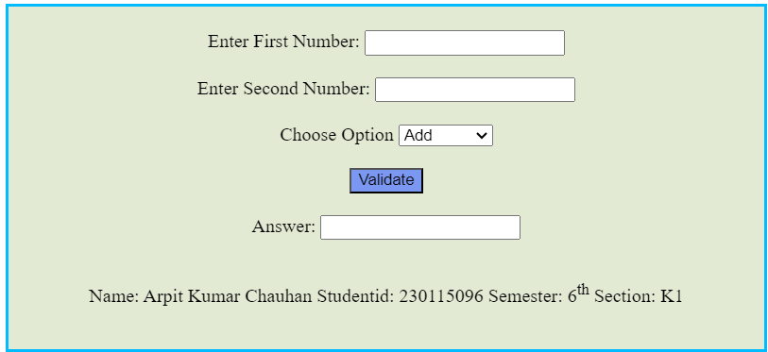

**Program No.:24**

**Program Title**

Design a web page that is self-modifying itself after every minute.

**Code**

<!DOCTYPE html>

<html lang="en">

<head>

    <meta charset="UTF-8">

    <meta name="viewport" content="width=device-width, initial-scale=1.0">

    <title>Self-Modifying Web Page</title>

    <style>

        #main

        {

            border:4px solid aqua;

            height:auto;

            width:600px;

            margin:20px auto;

            padding:20px;

            text-align: center;

            background: rgb(226, 234, 211);

        }

        h2{

            color:rgb(215, 109, 148);

        }

        .p1{

            color:blue;

            margin:15px;

        }

    </style>

</head>

<body>

    <div id="main">

        <h2>This Web Page is Update in every 5 seconds.</h2>

        <p id="content" class="p1">This page will change every minute.</p>

        <p class="p1">Last updated: <span id="timestamp"></span></p>

        <p>Name: Arpit Kumar Chauhan Studentid: 230115096 Semester: 6<sup>th</sup> Section: K1 </p>

    </div>

    <script>

        function modifyPage() {

            const messages = [

                "Hello, I am Arpit Kumar Chauhan!",

                "Did you know? This page updates every minute.",

                "Enjoy watching the content change automatically!",

                "Stay tuned for more updates!",

                "I am Studying in Graphic Era Hill University."

            ];

            document.getElementById("content").innerHTML = messages[Math.floor(Math.random() * messages.length)];

            document.getElementById("timestamp").innerHTML = new Date().toLocaleTimeString();

        }

        setInterval(modifyPage, 5000);

        modifyPage();

    </script>

</body>

</html>

**Screenshot of the output of program 24:-**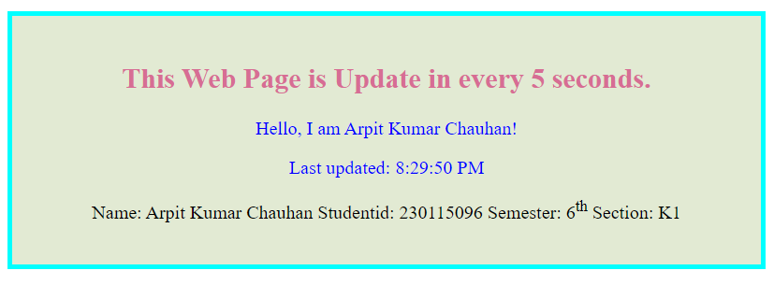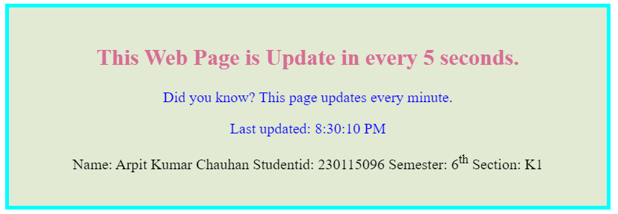

**Program No.:25**

**Program Title**

Write a code for a web application that accepts the user's birthdate in a textbox and displays the day of the week in a message box at the click of a button.

**Code**

<!DOCTYPE html>

<html lang="en">

<head>

    <meta charset="UTF-8">

    <meta name="viewport" content="width=device-width, initial-scale=1.0">

    <title>Find Your Birth Day</title>

    <style>

        #main

        {

            margin-top:30px;

            border:4px solid aqua;

            height:auto;

            width:600px;

            margin:200px auto;

            padding:20px;

            text-align: center;

            background: rgb(226, 234, 211);

        }

        h2{

            color:rgb(215, 109, 148);

        }

        button{

            color:blue;

            margin:15px;

        }

    </style>

</head>

<body>

    <div id="main">

    <h2>Find the Day You Were Born</h2>

    <label for="birthdate">Enter your birthdate:</label>

    <input type="date" id="birthdate">

    <br>

    <button onclick="findDay()">Find Day</button><br>

    <p>Name: Arpit Kumar Chauhan Studentid: 230115096 Semester: 6<sup>th</sup> Section: K1 </p>

    </div>

    <script>

        function findDay() {

            let birthdate = document.getElementById('birthdate').value;

            if(!birthdate)

            {

                alert("Enter date of Birth First!");

            }

            let day = ["Sunday","Monday","Tuesday","Wednesday","Thursday","Friday","Saturday"];

            let date = new Date(birthdate);

            alert("You were born on a " +day[date.getDay()]);

        }

    </script>

</body>

</html>

**Screenshot of the output of program 25:-**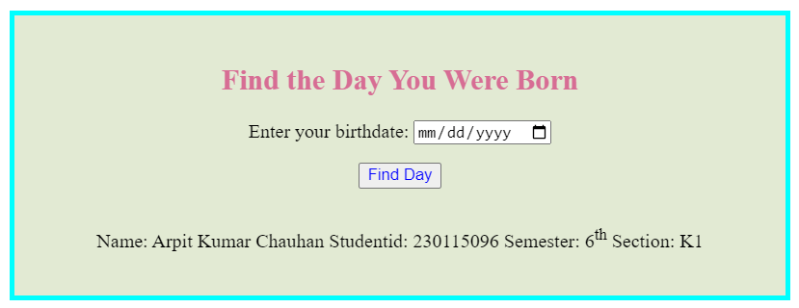

**Program No.:26**

**Program Title**

Write a script that inputs a telephone number as a string in the form (555)555-555. The script should use the strings method split to extract the area code as a token and the last four digits of the phone numbers as a token. Display the area code in one test field and the seven-digit phone number in another text field.

**Code**

<!DOCTYPE html>

<html lang="en">

<head>

    <meta charset="UTF-8">

    <meta name="viewport" content="width=device-width, initial-scale=1.0">

    <title>number</title>

    <style>

        #main

        {

            border:3px solid rgb(0, 187, 255);

            height:auto;

            width:600px;

            padding:20px;

            margin:20px auto;

            text-align: center;

            background: rgb(226, 234, 211);

        }

        button{

            background: rgb(122, 151, 241);

        }

    </style>

</head>

<body>

    <div id="main">

        <label for="num">Enter Phone Number : </label>

        <input type="number" id="num" name=""num>

        <br><br>

        <button type="button" onclick="validate()">Validate</button>

        <br><br>

        <label for="cc">Country Code : </label>

        <input type="text" id="cc" name="cc">

        <label for="pn">Phone Number : </label>

        <input type="text" id="pn" name="pn">

        <br><br>

        <p>Name: Arpit Kumar Chauhan Studentid: 230115096 Semester: 6<sup>th</sup> Section: K1</p>

    </div>

    <script>

        function validate()

        {

            let ans=document.getElementById('num').value;

            let cc = ans.substring(0,3);

            let pn = ans.substring(3,10);

            document.getElementById('cc').value=cc;

            document.getElementById('pn').value=pn;

        }

    </script>

</body>

</html>

**Screenshot of the output of program 26:-**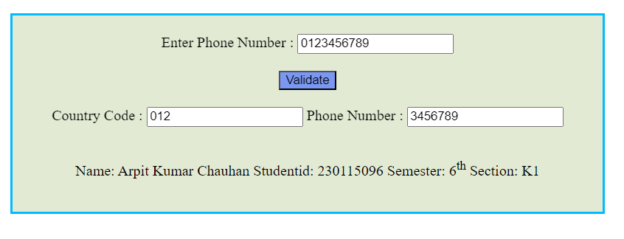

**Program No.:27**

**Program Title**

Develop and demonstrate an HTML file that includes a JavaScript script that uses functions for the following problems:

1. Parameter: A string

Output: The position in the string of the left-most vowel

1. Parameter: A number

Output: The number with its digits in the reverse order.

**Code**

<!DOCTYPE html>

<html lang="en">

<head>

    <meta charset="UTF-8">

    <meta name="viewport" content="width=device-width, initial-scale=1.0">

    <title>number</title>

    <style>

        #main

        {

            border:3px solid rgb(0, 187, 255);

            height:auto;

            width:600px;

            padding:20px;

            margin:20px auto;

            text-align: center;

            background: rgb(226, 234, 211);

        }

        button{

            color: blue;

            margin-top:10px;

        }

    </style>

</head>

<body>

    <div id="main">

        <label for="str">Enter String: </label>

        <input type="text" id="str">

        <br>

        <button onclick="find()">Find Vowel</button>

        <br>

        <p id="vow"></p>

        <label for="num">Enter String: </label>

        <input type="number" id="num">

        <br>

        <button onclick="rev()">Reverse Number</button>

        <p id="revans"></p>

        <p>Name: Arpit Kumar Chauhan Studentid: 230115096 Semester: 6<sup>th</sup> Section: K1</p>

    </div>

    <script>

        function find()

        {

            let word = document.getElementById('str').value;

            let vowel = "aAeEiIoOuU";

            for(let i=0;i<word.length;i++)

            {

                if(vowel.includes(word[i]))

                {

                    document.getElementById('vow').innerHTML="Left Most Vowel at the Position : "+(i+1);

                    document.getElementById('vow').style.color='green';

                    return;

                }

            }

            document.getElementById('vow').innerHTML="No Vowel Found!";

        }

        function rev()

        {

            let num = document.getElementById('num').value;

            let rev = num.split("").reverse().join("");

            document.getElementById("revans").innerText = "Reversed: " + rev;

            document.getElementById('revans').style.color='green';

        }

    </script>

</body>

</html>

**Screenshot of the output of program 27:-**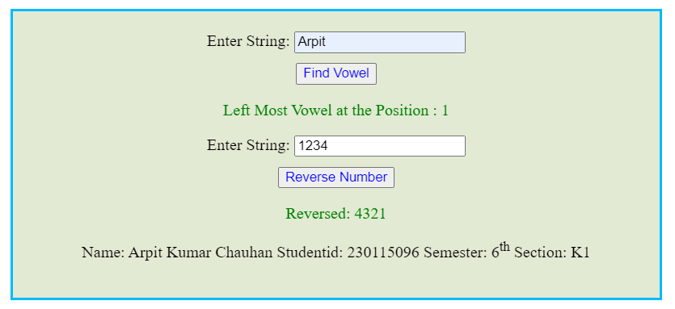

**Program No.:28**

**Program Title**

Write a JavaScript function that takes a string that has lower and upper case letters as a parameter and converts upper case letters to lower case and lower case letters to upper case.

**Code**

<!DOCTYPE html>

<html lang="en">

<head>

    <meta charset="UTF-8">

    <meta name="viewport" content="width=device-width, initial-scale=1.0">

    <title>Swap Case Converter</title>

    <style>

        #main

        {

            border:3px solid rgb(0, 187, 255);

            height:auto;

            width:600px;

            padding:20px;

            margin:20px auto;

            text-align: center;

            background: rgb(226, 234, 211);

        }

        button{

            color: blue;

            margin-top:10px;

        }

    </style>

</head>

<body>

    <div id="main">

        <h2>Swap Case Converter</h2>

        <input type="text" id="textInput" placeholder="Enter text here">

        <button onclick="swapCase()">Swap Case</button>

        <p><strong>Converted Text:</strong> <span id="output"></span></p>

        <p>Name: Arpit Kumar Chauhan Studentid: 230115096 Semester: 6<sup>th</sup> Section: K1</p>

    </div>

    <script>

        function swapCase() {

            let inputText = document.getElementById("textInput").value;

            let swappedText = inputText.split('').map(char =>

                char === char.toUpperCase() ? char.toLowerCase() : char.toUpperCase()

            ).join('');

            document.getElementById("output").innerHTML = swappedText;

            document.getElementById("output").style.color="green";

        }

    </script>

</body>

</html>

**Screenshot of the output of program 28:-**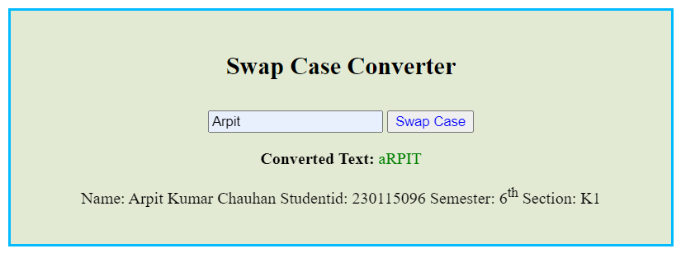

**Program No.:29**

**Program Title**

Design a web page to perform a survey on four different models of Maruti (Maruti -K10, Zen Astelo, Wagnor, Maruti- SX4) owned by people living in four metro cities(Delhi, Mumbai, Chennai & Kolkatta). Display tabulated report like format given below:

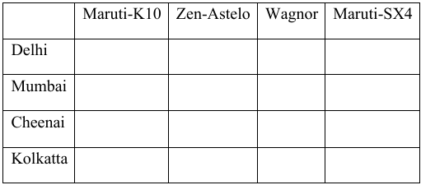

Calculate the number of cars of different models in each metro city.

**Code**

**Screenshot of the output of program 29:-**